PROBLEM STATEMENT

Adjust contrast in an image using histogram equalization

BEFORE CONTRAST

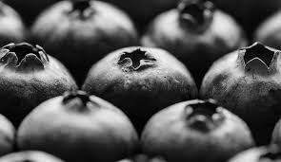

AFTER CONTRAST

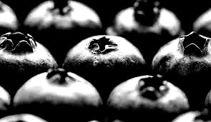

Let us consider an image whose pixel valuesa are confined to some range of values only. For eg: brighter image will have pixels to high values. But a good image will have pixels from all regions of image.

